Privacy preserving release of synthetic student records

Table of Contents
1 Introduction 1
2 Case introduction 1
2.1 Background and information at risk 1
2.2 Identity linkage attack 1
2.3 Sensitive attribute inference attack 1
3 Reasonable solution 1
3.1 Solution to identity linkage 1
3.2 Solution to sensitive attribute inference 2
3.3 Experimental design and metrics 2
3.4 Suppression policy and implementation 3
3.5 Results and recommended configuration 4
4 Reflection 5
5 Conclusion 6
References 7
Individual contribution 7
Appendix A Dataset provenance 8
Appendix B Evidence and reproduction 8

1 Introduction
This project examines a hypothetical research release of student results from a Canvas-like learning platform. Removing identifiers can leave students recognisable through combinations of age, postcode and programme. Their result bands may also be inferred without identifying an individual row. The project implements these attacks and compares identifier removal, k-anonymity and distinct l-diversity (Li et al., 2007; Machanavajjhala et al., 2006; Sweeney, 2002).
The primary objective is to preserve programme-level estimates of the proportion of marks below 50 while limiting disclosure. A paired experiment additionally tests whether a 10% suppression limit within every programme improves coverage. The recommended configuration is k=5, l=3 with both overall and programme limits, balancing the tested privacy requirements, programme coverage and retained demographic detail.

2 Case introduction

2.1 Background and information at risk
The proposed university release supports analysis of academic support needs. Each row represents one synthetic student in a hypothetical shared subject. Programme labels remain exact because programme comparisons are the intended use. Age and postcode are additional quasi-identifiers; the sensitive attribute is the result band. An inferred low result could expose academic difficulty. This is a simulated publication scenario; no actual Canvas export, student information or confirmed data breach is claimed.

2.2 Identity linkage attack
The attacker knows one target's exact age, postcode and programme and knows that the target appears in the particular release. Matching these values can locate a unique row and expose its result. Each target query is independent. A complete identified roster, private evaluation identifiers and knowledge of other students' grades are excluded. Suppressed students are excluded from the attack denominator and reported as lost coverage.

2.3 Sensitive attribute inference attack
Where several rows match, the attacker predicts the most frequent result band. A group containing only Below50 records reveals that outcome with certainty despite identity ambiguity. Homogeneous sensitive groups are a recognised weakness of k-anonymity (Machanavajjhala et al., 2006). The experiment also measures less certain predictions and inference of the binary below-50 or at-least-50 status.

3 Reasonable solution

3.1 Solution to identity linkage
The baseline removes the synthetic identifier and underlying mark, retaining exact quasi-identifiers and result bands. The first defence generalises age and postcode until each retained equivalence class E, defined by identical released quasi-identifiers, contains at least k records (Sweeney, 2002). The implementation tests k=5,10,20. Programme and sensitive values never change.
$$|E| ≥ k$$
Five age levels use exact values, 5-, 10- and 20-year intervals anchored at 18, and the complete 18-65 interval. Four postcode levels retain four, three, two or zero leading digits. These create 20 candidate mappings. Entire classes failing the privacy condition are suppressed; valid candidates must satisfy the release coverage limits. Rows are independently shuffled, with no identifiers or row indices exported.
The attack searches the released intervals and prefixes containing the target's exact values. Under an equal-likelihood assumption, a class of n candidates gives a random row guess probability of 1/n. This is a conditional ambiguity measure: it does not bound an attacker who also knows a student's result or other distinguishing information.

3.2 Solution to sensitive attribute inference
The second defence also requires at least l distinct result bands in every retained class, testing l=2,3 (Li et al., 2007). This is distinct-value l-diversity; frequency balance, entropy diversity and recursive diversity are not enforced. The additional condition is:
$$|\{ band(r) : r ∈ E \}| ≥ l$$
A separate hand-crafted dataset contains 20 students: ten Below50, five Pass and five Credit. Table 1 follows the candidate group for the same target. Under k=5, five matching students all have Below50 results, revealing the sensitive value. Generalising age further combines Below50 with other bands. The original marks remain unchanged; no records are suppressed in these examples.
Table 1 Matching groups for one target in the separate 20-student example
Release | Released age and postcode  Programme P01 throughout | Class size | Band counts
Identifier removal | 18; 9100 | 1 | Below50 1
k=5 | 18-22; 9100 | 5 | Below50 5
k=5, l=2 | 18-27; 9100 | 10 | Below50 5; Pass 5
k=5, l=3 | 18-27; 910* | 20 | Below50 10; Pass 5; Credit 5

Across this teaching dataset, unique linkage falls from 100% to zero under k=5, while single-band disclosure remains 100%. Adding l=2 or l=3 removes single-band disclosure and reduces modal-band accuracy to 50%. These constructed outcomes explain the mechanism and are analysed separately from the larger datasets.

3.3 Experimental design and metrics
Five fixed seeds, 2026-2030, generate 1,000 students each. Fictional programmes P01-P06 contain 320,260,180,120,80 and 40 students. Assumed age mixtures, postcode preferences and programme/context-dependent result probabilities create controlled variation. These are documented simulation assumptions, not estimates of UTS students. UTS supplies only numeric band boundaries: below 50, 50-64, 65-74, 75-84 and 85-100 (University of Technology Sydney [UTS], n.d.). Special grade statuses are excluded. Appendix A records provenance.
A binary unobserved study context is sampled with equal probabilities. Postcode subregions match that context with probability 0.85. Band probabilities mix 45% programme-specific probabilities with 55% context-specific probabilities. Consequently, the generated data contain controlled associations without treating location as a cause of achievement. All probability vectors are fixed in config.json before the comparisons; realised attack scores are not used to tune them.
Each seed uses the same source records for every setting. The first stage contains five identifier-removal baselines and 45 defended runs; the coverage extension pairs 45 additional runs with their original counterparts. Results are reported as five-seed means and full ranges, not confidence intervals.
Privacy metrics are unique-match percentage, single-band disclosure and modal-band prediction accuracy among retained targets. Class frequencies supply model-based confidence, with fixed public tie breaking. The primary utility metric is mean absolute error across the six programme below-50 rates, expressed in percentage points. Original rates use all source students; release rates use retained students. Missing programmes would make the aggregate undefined. Supporting utility is programme-level total variation between original and released band distributions.
For programme p, f(p) and g(p) denote original and released below-50 proportions. The primary metric gives every programme equal weight, preventing large cohorts from dominating the score:
$$MAE = \frac{100}{6}\sum_{p=1}^{6}{|g(p) - f(p)|}$$
For the supporting check, calculate half the sum of absolute differences between the five band proportions within each programme, then average across programmes. Both metrics compare the release with the complete synthetic source, so suppression effects remain visible.
Generalisation loss averages age interval span divided by 47 and postcode represented-leaf count minus one divided by 39. It ranges from zero to one. Candidate selection minimises this equally weighted loss over all original rows before suppression, then lower suppression and hierarchy indices break ties. This measures discarded demographic detail separately from programme-level accuracy.

3.4 Suppression policy and implementation
The original policy permits at most 10% removal overall. The extension applies the same limit within each programme. With original count N and retained count R, suppression is (N-R)/N; each programme applies this calculation to its own counts. The additional rule changes candidate eligibility while preserving the hierarchy and selection objective.
sizes = group.transform("size")
diversity = group.transform("nunique")
keep = (sizes >= k) & (diversity >= ell)
by_programme = programme_suppression(raw, keep)
cap_ok = (by_programme.n_removed <=
programme_cap * by_programme.n_original + 1e-9).all()
The extract combines core checks from experiment.py and compare_policies.py. Rejected candidates remain in the audit. The programme cap is a coverage requirement; it introduces no stronger anonymity definition. Infeasible settings are reported rather than repaired by changing results.
For every selected release, the implementation independently executes the public-data matching attack on each retained target and verifies its accuracy against private ground truth. Additional checks cover exact suppression boundaries, unchanged programme/band multisets, hierarchy containment, reproducibility and infeasible single-band cases. Hash comparison preserves 270 original experimental files during the policy extension, isolating the effect of the additional constraint.

3.5 Results and recommended configuration
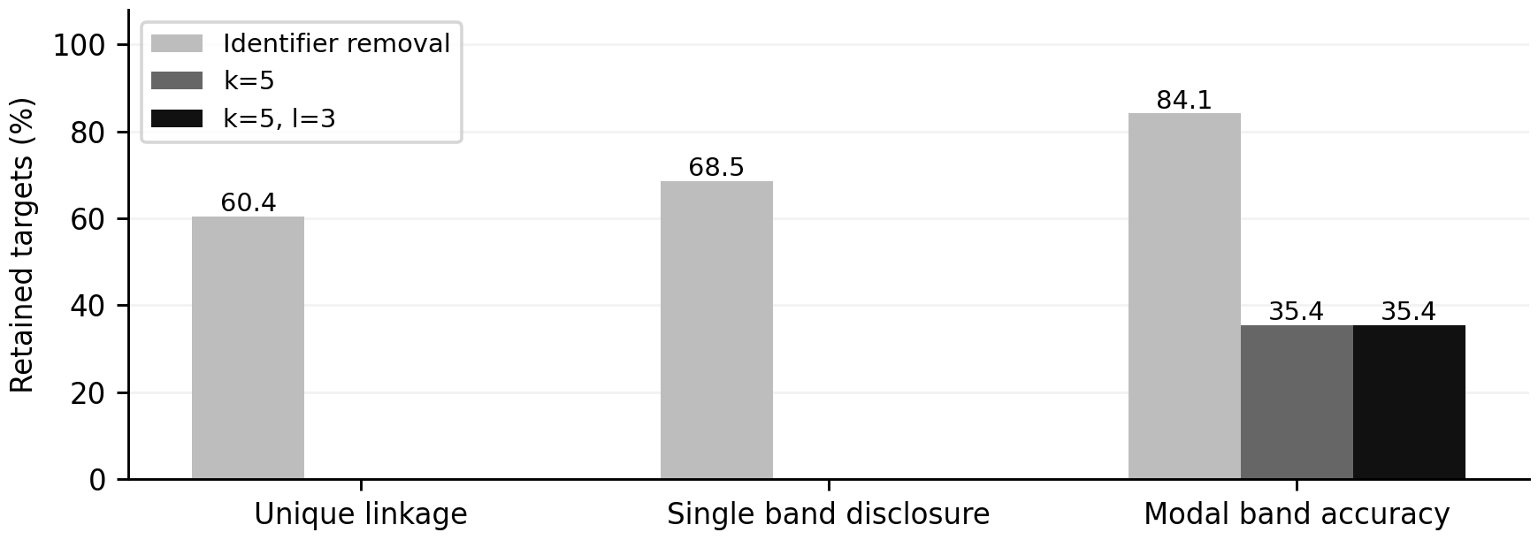
Figure 1 Original policy privacy results across five seeds. Bars show mean percentages; baseline identifiers are removed. The k=5 variants use the same overall suppression cap. Their overlapping results show limited additional diversity benefit in these datasets.
Identifier removal leaves 60.44% of records uniquely linkable and 68.52% in single-band groups. Every defended main-data release has zero unique matches and zero single-band disclosure under the stated attacker model. However, k-only already produces diverse groups: adding l=2 changes no original selected output, and l=3 changes only one of 15 seed/k comparisons. Figure 1 therefore supports anonymisation's benefit while showing limited additional empirical benefit from diversity in these datasets.
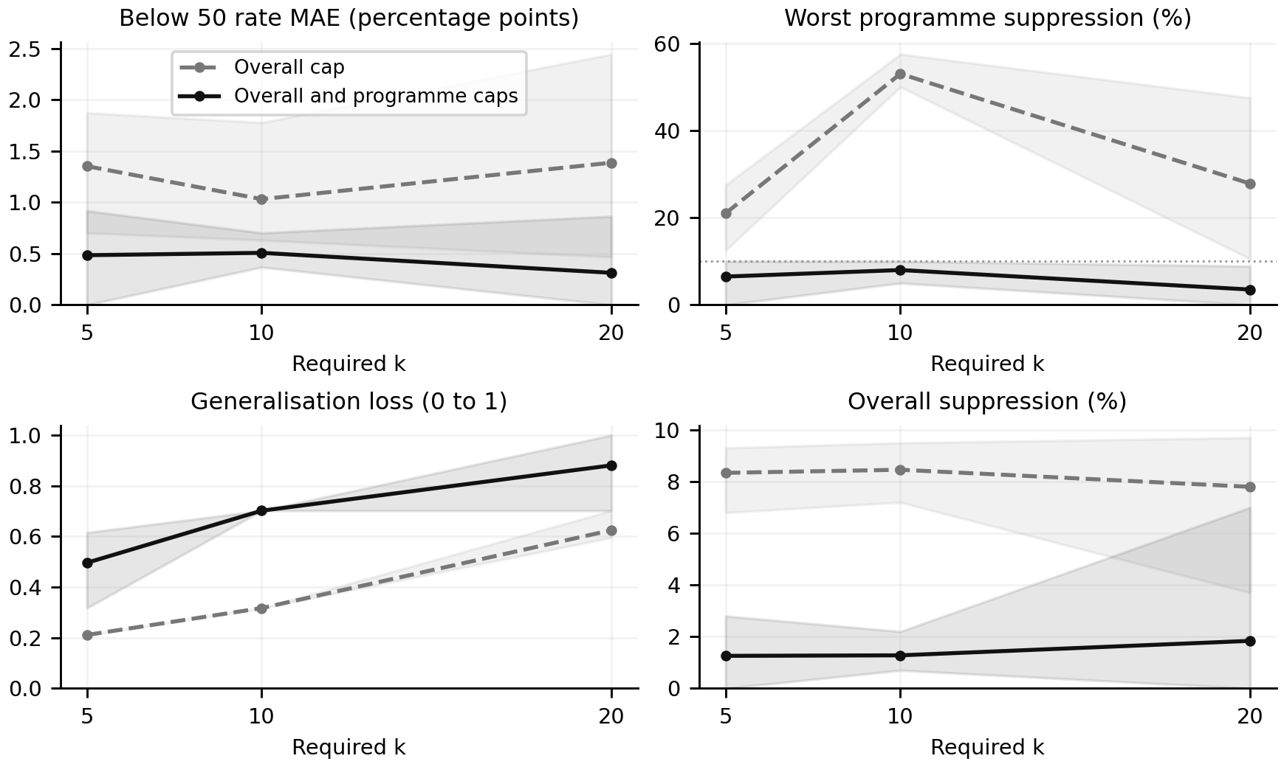
Figure 2 Suppression policy comparison with l=3. Lines show five-seed means and shading shows full ranges, not confidence intervals. Worst programme suppression is calculated within each run. The programme cap trades age/postcode detail for coverage and improved average programme accuracy.
The overall cap conceals concentrated losses. For seed 2026 at k=10,l=3, 91 of 1,000 records are removed, including 23 of P06's 40 students. Only 17 remain for its programme estimate. The extension limits observed programme suppression to 10% throughout all settings. At k=10,l=3, mean utility error falls from 1.032 to 0.508 percentage points and overall suppression from 8.46% to 1.28%, while generalisation loss rises from 0.317 to 0.702 (Figure 2).
The recommended k=5,l=3 configuration with both caps has mean below-50 error of 0.485 percentage points, ranging from 0 to 0.918, and mean suppression of 1.26%. Supporting total variation averages 0.00870. Generalisation loss is 0.496, compared with 0.702 at k=10 and 0.881 at k=20 under the same policy. Although k=20 lowers mean primary error to 0.313 points, it discards substantially more demographic detail. The recommendation preserves more of that secondary value while meeting the chosen constraints.

4 Reflection
The coverage comparison changed how I assessed a successful release. An overall loss below 10% initially appeared acceptable, but P06's 57.5% exclusion showed that a large programme can dominate the aggregate. The programme cap makes the retention requirement meaningful for the actual research question. It also demonstrates why suppression and generalisation need separate measures: stronger generalisation retained more records and improved programme analysis even though the demographic information became less precise.
The improvement is conditional. Error decreased in 42 of 45 paired comparisons and increased in three. Those three represent the same seed/k outcome repeated across methods, so they are not independent observations. The extension was chosen after inspecting the original results and should be treated as exploratory. More seeds, alternative generating relationships and external validation would be needed before claiming general effectiveness. Synthetic postcode prefixes and assumed grade probabilities limit transfer to actual student populations.
The small example establishes a weakness that happened not to dominate the larger datasets. It would be misleading to use its 100% disclosure rate as a general estimate or attribute the coverage benefit to l-diversity: under the programme cap, k-only and both diversity variants select identical outputs for every seed/k pair. The reason for retaining l=3 is an explicit minimum diversity requirement, supported by the worked counterexample, rather than consistent superiority in the sampled data.
Distinct bands also leave residual inference. A constructed group with 19 Pass and one Below50 record satisfies l=2 while giving 95% modal confidence. In the recommended main-data releases, a mean 0.103% of retained targets still have certain at-least-50 status because different bands can share that meaning. Modal-band accuracy remains 34.34%, compared with 32.42% for a programme-only predictor computed from the same releases. Entropy diversity or t-closeness could address additional distributional concerns (Li et al., 2007; Machanavajjhala et al., 2006), but neither is evaluated here. Auxiliary knowledge and intersections between repeated releases require separate testing.
The implementation searches only the declared 20 candidates, so its optimum is local to that hierarchy and loss rule. The 22 automated checks verify constraints, unchanged values, attack calculations and original-file preservation; they do not prove protection against every attacker. Before operational release, the university would need to validate actual quasi-identifiers and downstream usefulness, approve one release configuration and prevent disclosure of private evaluation mappings. Appendix B identifies the reproducibility evidence.

5 Conclusion
The implemented attacks show that identifier removal can expose both identity and results in synthetic student microdata. Generalisation and suppression prevent unique linkage under the defined model, while diversity addresses the homogeneous-group mechanism. For the selected programme analysis, the additional programme cap improves coverage and average utility at a measurable cost in demographic detail. I recommend k=5,l=3 with both 10% suppression limits as a balanced configuration for this simulation, subject to its stated assumptions and residual inference risks.

References
Li, N., Li, T., & Venkatasubramanian, S. (2007). t-closeness: Privacy beyond k-anonymity and l-diversity. In 2007 IEEE 23rd International Conference on Data Engineering (pp. 106–115). IEEE. https://doi.org/10.1109/ICDE.2007.367856
Machanavajjhala, A., Gehrke, J., Kifer, D., & Venkitasubramaniam, M. (2006). l-diversity: Privacy beyond k-anonymity. In 22nd International Conference on Data Engineering (ICDE’06) (p. 24). IEEE. https://doi.org/10.1109/ICDE.2006.1
Sweeney, L. (2002). k-anonymity: A model for protecting privacy. International Journal of Uncertainty, Fuzziness and Knowledge-Based Systems, 10(5), 557–570. https://doi.org/10.1142/S0218488502001648
University of Technology Sydney. (n.d.). Grading schema for coursework subjects. https://www.uts.edu.au/for-students/current-students/managing-your-course/attendance-and-study-load/results/grading-schema-coursework-subjects

Individual contribution
I selected the scenario, synthetic-data approach, analysis tasks, exact programme field, suppression-policy comparison and recommended configuration through discussion. AI assistance supported coding, data preparation, analysis and report drafting under my control. The experiment was executed in my own computing environment.

Appendix A Dataset provenance
All 5,000 main records and 20 teaching records originate in the project generator. No external student records were collected. The register separates sources of definitions from sources of values.
Table A1 Source and transformation register
Component | Origin | Recorded evidence
Synthetic records and marks | Project generator G1 | experiment.py; config.json
Age postcode and programme values | Experimental assumptions G1 | data_dictionary.csv
Numeric band boundaries | UTS (n.d.) | source_register.json entry S1
Attack and defence definitions | Li et al. (2007); Machanavajjhala et al. (2006); Sweeney (2002) | source_register.json entries S2-S4
Auxiliary target queries | Source synthetic quasi-identifiers | Private query batches
Programme cap releases | Policy transformation G2 | policy_comparison/release_provenance.csv

The configuration fixes seeds, programme counts, age mixtures, postcode hierarchy and all conditional probabilities. Marks are sampled within their assigned bands. The private target-query batches copy only synthetic identity labels and quasi-identifiers; each query represents separate background knowledge. Identifiers and marks are excluded from every public release.

Appendix B Evidence and reproduction
Table B1 Evidence index
Evidence | Supplementary package location
Origin of every source record | record_provenance.csv
Original results and release audits | results/ and audit/
Paired metrics and 22-check log | policy_comparison/results/
Coverage comparison figures | policy_comparison/figures/
File integrity register | evidence_manifest.csv

Run experiment.py, compare_policies.py and python -m unittest -v after installing requirements.txt. The recorded environment is Python 3.12.14, NumPy 2.3.5, pandas 2.2.3 and Matplotlib 3.10.8. Private truth and alternative releases are supplied only for synthetic reproducibility; publishing multiple versions of real student data would require an intersection-risk assessment.

